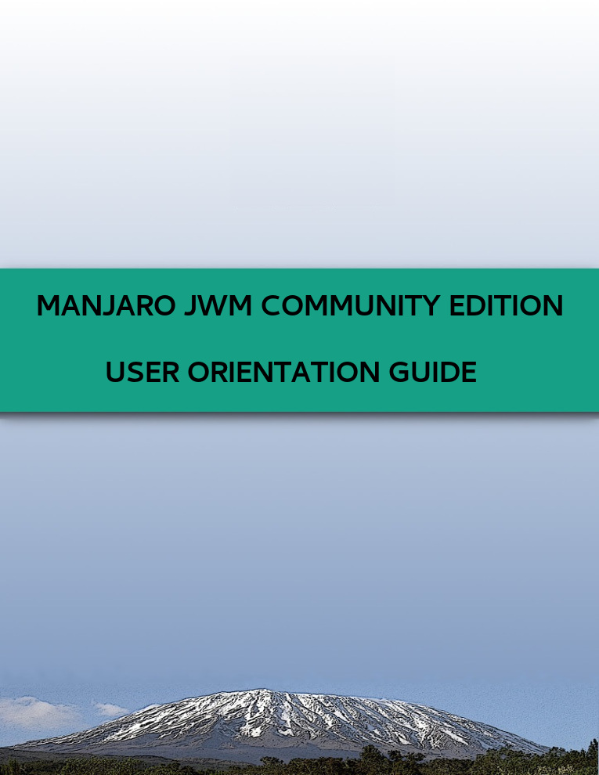

:: Welcome to Manjaro JWM Community Edition ::
:: 16.dev I Code... I Daniella::



Contents

1. Overview
2. General Observations
3. Shortcuts
3.1. Application Shortcuts
3.2. Screen Lock Shortcut
3.3. Reconfigure (Restart) JWM Shortcuts
3.4. Pacli Package Manager Shortcut
3.5. JWMConf Configuration Tool Shortcut
3.6. Audio Shortcuts

3.7. Screenshot Shortcut
3.8. Windows Shortcuts
3.8.1. Tiling
3.8.2. Changing the Virtual Desktop
3.8.3. Sending the Focused Window to a Certain Virtual Desktop
4. Key Applications Installed by Default in Manjaro JWM Community Edition
5. Script All: Scripts to Install Additional Features
6. How to Make a Bootable Live USB
7. Menus in JWM

8. How to Reconfigure JWM and Load Changes

9. How to Enable and Disabled Services

10. Changing the Weather (City and Temperature) in Conky

11. LXMusic: Change PulseAudio for ALSA - Advanced Linux Sound Architecture

12. How to Install Display Managers (if you want to replace LXDM)

13. How to Edit Pacli and JWMConf

14. How to Exit and Lock the Screen

1. Overview

Manjaro Linux is a fast, user-friendly, desktop-oriented operating system based on Arch Linux. Key features include intuitive installation process, automatic hardware detection, stable rolling-release model, ability to install multiple kernels, special Bash scripts for managing graphics drivers and extensive desktop configurability. For more information: http://manjaro.org/.

JWM (Joe's Window Manager), the default Manjaro JWM Community Edition window manager (WM), is a featherweight WM for Xorg written in C. It is under active development and maintained by Joe Wingbermuehle. It is also the default window manager base for distributions such as Puppy Linux and Damn Small Linux. JWM uses approximately 5 MB of resident memory under normal operating conditions. As of January 2009, the size of the version present in the official Arch Linux repositories is under 76 KB packaged (compare to dwm, another WM, but tilling style, at under 17 KB) and under 171 KB installed (compare to dwm at 68 KB). A minimally compiled version consumes approximately 136 KB of disk space and occupies under 1500 KB of resident memory (RAM). For more information: http://joewing.net/projects/jwm/index.shtml.

2. General Observations

• The default mod-key, that is commonly used in shortcuts, is <Mod4> (Super-key, aka., Windows-key). Example: if you press ' Super + t ' it opens Sakura terminal.
• Another mod-key is <Mod1> (Alt-key). Example: if you press ' Alt + F2 ' it opens the focused window JWM's window menu.
• To comment on some parameter in JWM files use the following syntax (that is XML):
'<!--' input parameter '-->'. To uncomment, remove '<!--' '-->'.
• To run any command and/or open an application with Gmrun, you can go to Execute (in Menu).
• To open the default terminal, Sakura, you can go to Terminal (in Menu).
• To open Pacli, the default Package Manager in Manjaro JWM Community Edition, you can go to Pacli (in Menu).
• To open JWMConf, the default Configuration Tool for JWM, you can go to JWMConf (in Menu).
• To open the default file manager, PCManFM, you can go to File Manager (in Menu).
• To open the default web browser, Pale Moon (Firefox lightweight fork), you can go to Web Browser (in Menu).
• To take a screenshotof your desktop, you can go to Screenshot submenu and chose one of the available options (in Menu). Alternatively simply press the Printscreen (PrtScr) key.
• To change the wallpaper, you can go to Nitrogen Wallpaper (in Menu -> Settings).

3. Shortcuts

3.1. Application Shortcuts

• To run any commands and/or open an application with Gmrun = < Mod4 + r>.
• To open Sakura terminal = < Mod4 + t>.
• To open PCManFM file manager = < Mod4 + e>.
• To open Pale Moon web browser = <Mod4 + b>.
• To minimize all the windows = < Mod4 + d>

3.2. Screen Lock Shortcut

• To lock the screen with i3lock = <Mod4 + l>.

3.3. Reconfigure (Restart) JWM Shortcut

• To reconfigure (restart) JWM = <Mod4 + u>.

3.4. Pacli Package Manager Shortcut

Pacli is a simple CLI (terminal) frontend for Pacman/Yaourt (AUR). Also is the application to update your system.

• To open Pacli = <Mod4 + p>.

3.5. JWMConf Configuration Tool Shortcut

JWMConf is a CLI (terminal) tool to manage JWM config files, like keys, themes, tray and more.

• To open JWMConf = <Mod4 + j>.

3.6. Audio Shortcuts

Besides the “XF86Audio keys”, that some keyboard already brings to raise, lower or mute volume (some dedicated keys and/or some keys marked with blue icons), Manjaro JWM Community Edition also brings the following shortcuts:

• To set volume up by 5% ('Amixer set Master 5%+') = <Mod4 + PgUp>.
• To set volume down by 5% ('Amixer set Master 5%-') = <Mod4 + PgDn>.
• To toggle (and untoggle) volume mute ('Amixer set Master toggle') = <Mod4 + 0>.

Anyway, the XF86Audio keys remain doing its functions, this alternative shortcuts are mainly aimed to keyboards that don't bring these dedicated keys.

3.7. Screenshot Shortcut

All the screenshots you take in Manjaro JWM Community Edition will be placed in the Screenshots folder at your home directory (and a tiny notification will pop-up if everything went fine).

• To take a screenshot = <Print> (PrtScr).

3.8. Windows Shortcuts

3.8.1. Tiling

The “aerosnap” effect, to anchor the windows to the screen edges.

• To place a window in the top half of the screen = <Mod4 + Up>.
• To place a window in the bottom half of the screen = <Mod4 + Down>.
• To place a window in the left half of the screen = <Mod4 + Left>.
• To place a window in the right half of the screen = <Mod4 + Right>.

And to 'undock' a window from any position and bring it back to the previous position just press the same shortcut again.

3.8.2. Changing the Virtual Desktop

By default, Manjaro JWM Community Edition comes with two virtual desktops, you can be see this at a little pager in Tray (the bottom panel). This can be changed in the file /home/username/.jwm/preferences , in the section:

<!-- Virtual Desktops -->
<!-- Desktop tags can be contained within Desktops for desktop names. -->
<Desktops width="2"></Desktops>

Where you can change this number '2 ' by any number you want.

• To change to the right virtual desktop = <Ctrl + Alt + Right>.
• To change to the left virtual desktop = <Ctrl + Alt + Left>.

3.8.3. Sending the Focused Window to a Certain Virtual Desktop

These shortcuts are particularly useful when dealing with several application windows and you want to “clear the area”, but not yet close some programs. Example: to send a music player or an e-mail client to the next virtual desktop, but leaving them open.

• To send the focused window to the right virtual desktop = <Shift + Alt + Right>.
• To send the focused window to the left virtual desktop = <Shift + Alt + Left>.

Note that the virtual desktop will remain the same, only the window will be sent to the assigned desktop. Don't worry, it is not that your window “vanished”, you can easily get back to it by changing your virtual clicking the pager on the Tray (or using the shortcuts).

4. Key Applications Installed by Default in Manjaro JWM Community Edition

You can easily find all default installed applications in Manjaro JWM Community Edition in the Menu by right clicking the desktop or clicking the Menu button in Tray (the bottom panel). And quick a tip: it is also available with the shortcut 'Super + F1'. Here they are:

In Screenshot (Menu -> Screenshot):
There are four preconfigured ways to take a screenshot of you screen in Manjaro JWM Community Edition. All of them use a tiny program called “scrot” and the titles are self explained:
• Active Window Delay.
• Active Window.
• Full Screen.
• Select Area.

In Accessories (Menu -> Accessories):
• ImageWriter ISO/USB, a graphical utility for writing raw disk images & hybrid isos to USB keys.
• Leafpad Editor, the name says it all.
• Medit Editor, useful to edit JWM config files, because it recognizes XML syntax.
• Xarchiver Compressed, to (un)compress files, as zip, tar.gz, tar.bz2 and even rar (through a plugin).

In Graphics (Menu -> Graphics):
• Online Image Editor, opened in Pale Moon (http://www.online-image-editor.com/).

In Multimedia (Menu -> Multimedia)
• LXMusic Music Player, very light, yet does job fine.
• SMPlayer Video Player, very complete media center, can even play videos from YouTube (go to File -> URL… and paste the YouTube video link).

In Network (Menu -> Network)
• HexChat IRC, powerful IRC communication tool, and feel free to ask about Manjaro JWM Community Edition at the default channels #manjaro and #manjaro-br (in Brazilian Portuguese), or even to chitchat at #manjaro-talk .
• Pale Moon Browser, a lightweight Firefox fork.

In Office (Menu -> Office)
• AbidWord Word, it is the GTK2 version, even more lightweight, yet very complete word processor.
• ePDFView PDF, simple PDF viewer.
• Gnumeric Calc, light spreadsheet program.

• Online PDF Tools, simple tools to edit and convert PDFs files, opened in Pale Moon (http://smallpdf.com/).
• Simple Scan, full-featured scanner application.
In Settings (Menu -> Settings)
• ArandR Screen Editor, to change screen resolution, rotate and manage multiple monitors.
• Blueman Adapters, to manage Bluetooth support.
• Blueman Manager, to manage connected (or not yet) Bluetooth devices.
• Configure Mouse/Keyboard (LXInput), simple tool to configure (guess what?) keyboard and mouse.
• Customize Look/Feel (LXAppearance), to change icons, fonts, GTK+ theme and more.
• Manjaro Settings Manager, simple but powerful tool to manage kernels, time (and timezone), keyboard layouts and more.
• Nitrogen Wallpaper, a simple and light tool to set the wallpaper.
• Personalize LXDM, to configure LXDM login manger, changing the theme or set auto-login and more.
• Printer Settings, as the name says, to add and manage printers (it is activated after 'Printing' is installed in Menu -> System -> Script All).

In System (Menu -> System)
• Script Install, a small but very useful collection of scripts to install support for, Firewall, Additional Multimedia Codecs, OpenJDK and Printing (see the next item).

• Gufw Firewall, to set and manage firewalls (it is activated after 'Firewall' is installed in Menu -> System -> Script All).
• HardInfo, very complete hardware information and benchmark tool.
• HTop Processes, to watch and manage (change the priority, stop or even kill) running applications and services.
• JWMConf Configuration Tool, a CLI (terminal) tool to manage JWM config files, like keys, themes, tray and more.
• Pacli Package Manager, a simple CLI (terminal) frontend for Pacman/Yaourt (AUR). Also is the application to update your system.
• Privilege Granting, to change super-user (root) privileges and settings (use it carefully).
• Root File Manager (PCManFM), to manage files with super-user (root) access (use it carefully).
• Root Terminal (Sakura), super-user (root) terminal session (you know you have to use it carefully, right?)
• Temperature Sensors (Xsensors), small and simple tool to watch your hardware temperature.

5. Script All: Scripts to Install Additional Features

In the Script All sub-menu you can find simple scripts to add even more features to Manjaro JWM Community Edition. Just click them, follow the instructions in the terminal that will show up, and all the installation process should be done fine. (Requires internet connection.)
• Firewall: Support for firewall, through Gufw Firewall application = in Menu -> System -> Script All -> Firewall.
• Multimedia: Support for additional multimedia codecs = in Menu -> System -> Script All -> Multimedia.
• OpenJDK: Support for OpenJDK, free and open source implementation of Java = in Menu -> System -> Script All -> OpenJDK.
• Printing: Support for printing documents and install printers = in Menu -> System -> Script All -> Printing.

Obs.: After installation, the script can be removed using the 'Edit Menu JWM' option (number 4) in Menu -> JWMConf. For example, after Firewall is installed, you can remove the line:

<Program icon="/usr/share/icons/Ultra Flat Orange/apps/scalable/script.svg" label="Firewall">gksu xterm ~/.scripts/firewall.sh</Program>

The menu entry System -> Script All -> Firewall will disappear (after you restart JWM).

6. How to Make a Bootable Live USB

• To write a ISO image (of some Linux distribution you downloaded, for instance) to a USB stick, you can use ImageWriter ISO/USB, a graphical utility for writing raw disk images & hybrid isos to USB keys (Menu -> Accessories).

7. Menus in JWM

The menu in JWM is called “root menu” and can be a fast and easy way to start applications. It also provides a way to restart or exit the session (to restart or shutdown your computer). Note that multiple root menus are possible. You can find more information about the 'onroot' attribute and many more here: http://joewing.net/projects/jwm/config.shtml#root .

Look at this example, the outer-most tag is 'RootMenu':

<RootMenu onroot="3">
<Program label="Execute">gmrun</Program>
<Program label="Terminal">sakura</Program>
<Program label="Explorer">pcmanfm</Program>
<Program label="Browser">palemoon</Program>
<Program label="Background">nitrogen</Program>
<Program label="Screenshot">gnome-screenshot</Program>
<Separator/>
<Menu label="Accesories">
<Program label="Catfish Search">catfish</Program>
<Program label="ClipIt Manager">clipit</Program>
<Program label="Medit Editor">Medit</Program>
<Program label="Leafpad Editor">leafpad</Program>
<Program label="Xarchiver Compact">xarchiver</Program>
</Menu>
</RootMenu>

You can see that 'RootMenu' is combined with the ' onroot=”3” ' attribute. By default, JWM reads this number '3' as the mouse desktop right click, so this example menu would be shown when you right click any empty area of your desktop. Note that Manjaro JWM Community Edition brings the exactly the same menu if do a desktop right click or if you click “Menu” in the Tray (the bottom panel).

For more information, and also on several other JWM configuration standards: http://joewing.net/projects/jwm/config.shtml

Obs.: To be able to access any change in the menus you need to restart JWM. More on this bellow.

8. How to Reconfigure JWM and Load Changes

To be able to access any change in the menus (as themes, shortcuts, menu or any aspect of JWM), you need to restart JWM. To do this you can go to JWMConf -> then choose the very first option, “Refresh Configuration JWM, by typing the number '1'. This will refresh only JWM (and its configuration, of course), all the applications you may be using will remain opened. There is no need to logout and login again (or to restart the computer). Alternatively, you can use the shortcut 'Super + u' (it is the same effect).

9. How to Enable and Disabled Services

The following services are disabled: Cbatticon (cbatticon -u 120 -i standard -c "systemctl suspend" -l 20 -r 5) and Blueman (blueman-applet). If you want to enable the services you can proceed as follows: go to Menu -> JWMConf, choose the option “Edit Start JWM” (by typing the number '6') and add the following lines:

<StartupCommand>cbatticon -u 120 -i standard -c "systemctl suspend" -l 20 -r 5<StartupCommand>
<StartupCommand>blueman-applet</StartupCommand>

Alternatively, you can open the file /home/username/.jwm/start and edit it in a text editor (Medit is recommended).

After a reboot the services will be running.

10. Changing the Weather (City and Temperature) in Conky

To change the default city and weather in Conky, you should go to http://weather.noaa.gov/ and search for your country and then for the city nearest to you. This will lead you to a webpage-address that looks like this: http://weather.noaa.gov/weather/current/XXXX.html where this XXXXis the four letter code for your city. The same four letters need to replace SBVT in line 24 of the original Conky config. It is also necessary to change the city name from Vitória (ES) to wherever city you want.

${voffset 10}$alignr$color Vitória (ES) ${weather http://weather.noaa.gov/pub/data/observations/metar/stations/ SBVT temperature temperature 15}°C
Obs.: To access the Conky config you can go to Menu -> JWMConf, then choose the option “Edit Conky”, by typing the number '15'.

11. LXMusic: Change PulseAudio for ALSA - Advanced Linux Sound Architecture

To be able to listen to your favorite songs and audio files, first you need to open LXMusic in Menu -> Multimedia, then go to File -> Preferences -> Audio. In Plug-in change “PulseAudio” for “ALSA - Advanced Linux Sound Architecture”. Press in OK and restart LXMusic.

12. How to Install Display Managers (if you want to replace LXDM)

To install other display managers, if you want to replace Manjaro JWM Community Edition's default, LXDM, please visit the following link: https://wiki.manjaro.org/index.php?title=Install_Display_Managers .

13. How to Edit Pacli and JWMConf

If you want to edit some of the features of Pacli Package Manager and/or JWMConf Configuration Tool, you can find both programs (that actually are shell scripts) at the folder:

/home/username/.managers/

Note that this '.' before 'managers' means that this folder is hidden by default. To show it in PCManFM (and most file managers) you can go to View (in the menu bar) -> Show hidden files (or use the shortcut 'Ctrl + h').

Then you can open and edit these files in a text editor (Medit is recommended).

14. How to Exit and Lock the Screen

After 20 minutes of screen idleness (no mouse and/or keyboard movement) Manjaro JWM Community Edition locks the screen with a tool called i3lock (for security). Some images of i3lock running:







To unlock your screen you must enter your user password.

Thank you for using this edition and enjoy the simplicity and lightness of Manjaro JWM Community Edition 16.dev I Code… I Daniella.

Regards,

Holmes, Manjaro JWM Community Edition Maintainer.
Bruno Conde (blconde), Manjaro JWM Community Edition Tester and Documentation.

A special thanks to all Manjaro Community that, through Manjaro Forums and more, helped a lot to bring this release.

